Task 8.2

Isaac Pittolo – 7695438  
Hoang Linh Bui – 100017631  
Adam Bubonya – 9986677

## 28th Apr

Meeting Minutes as of 28 Apr

Duration: 5 minutes

Time: 9:30pm

Location: Skype Call

Attendees: IP, AB, HB

Summary

Discussed changes to current demo functionality from previous week

Actions:

29th APR – AB to commit additional details to software

## 29th Apr

Meeting Minutes as of 29 Apr

Duration: 6 minutes

Time: 9:50pm

Location: Skype Call

Attendees: AB, HB

Summary

Console App Update pushed by HB

Demo Functionality moved back to Doing

“Show Sales” added

Actions  
APR 30th - HB finished show inventor, no inventory to test as of yet. To add Inventory.

## 2nd May

Meeting Minutes as of 28 Apr

Duration: 8 minutes

Time: 9:30pm

Location: Skype Call

Attendees: IP, AB, HB

Summary

Sales record functions need to be worked on.

Actions:

3rd May – IP to commence work on Sales Records, implement with Demo functionality.  
3rd May – HB to proof read documentation

## 3rd Apr

Meeting Minutes as of 3 May

Duration: 4 minutes

Time: 9:45pm

Location: Skype Call

Attendees: IP, AB, HB

Summary

IP pushed what he could, began working on Inventory.

AB and HB to continue with their portion of demo

Actions:

29th APR – AB to commit additional details to software

## 4th Apr

Meeting Minutes as of 4th Apr

Duration: 5 minutes

Time: 9:30pm

Location: Skype Call

Attendees: IP, AB, HB

Summary

Prepared for presentation of Demo functionality – needs a bit more work

Currently not quite there, additional functionality recommended – move test core material to live system.

## Repository Changes as of End of Week 2 – Sprint 2

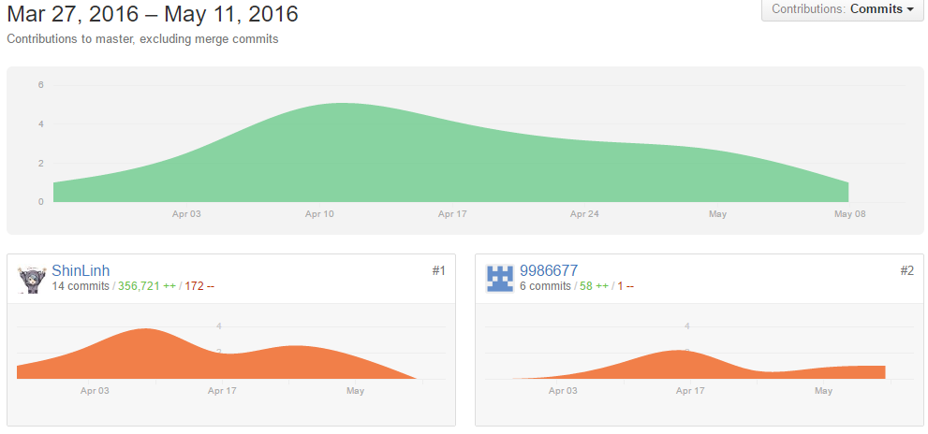

### Repository Root Directory

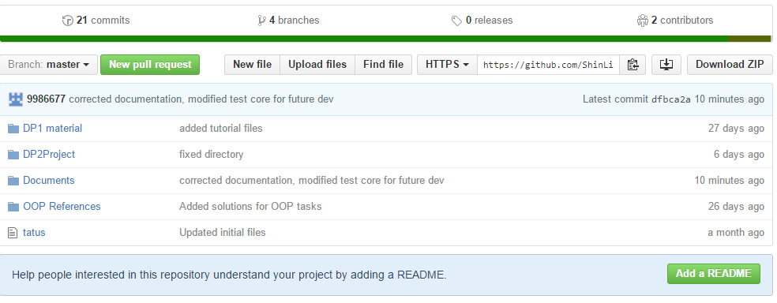

### Code Frequency

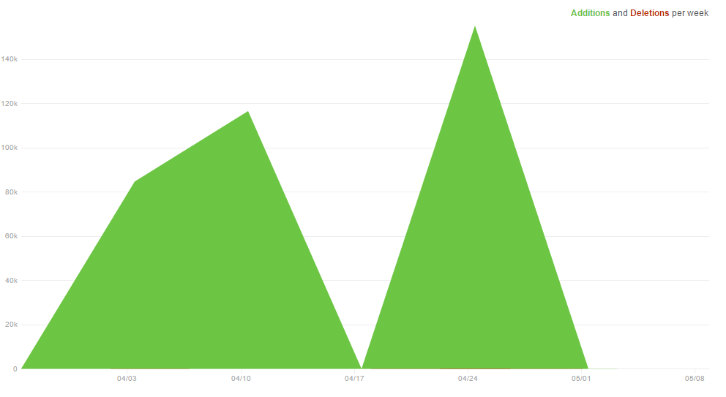

### Discussion

As a group we have performed considerably better in comparison to the first sprint.

We have achieved a functional demo with working functions, more to be added in the future. All in all in comparison to the previous sprint we have been doing quite well and I look forward to the progress we will make in future sprints.